**Setting up Ubuntu machine within VMBOX**

Download Oracle VMBOX (as per your OS) from

<https://www.virtualbox.org/wiki/Downloads>

Download ubuntu 18.04 disc image iso (amd64-desktop image) from

<http://releases.ubuntu.com/16.04/>

**Adding an empty machine to VMBOX**

**Open VMBOX > click on new**

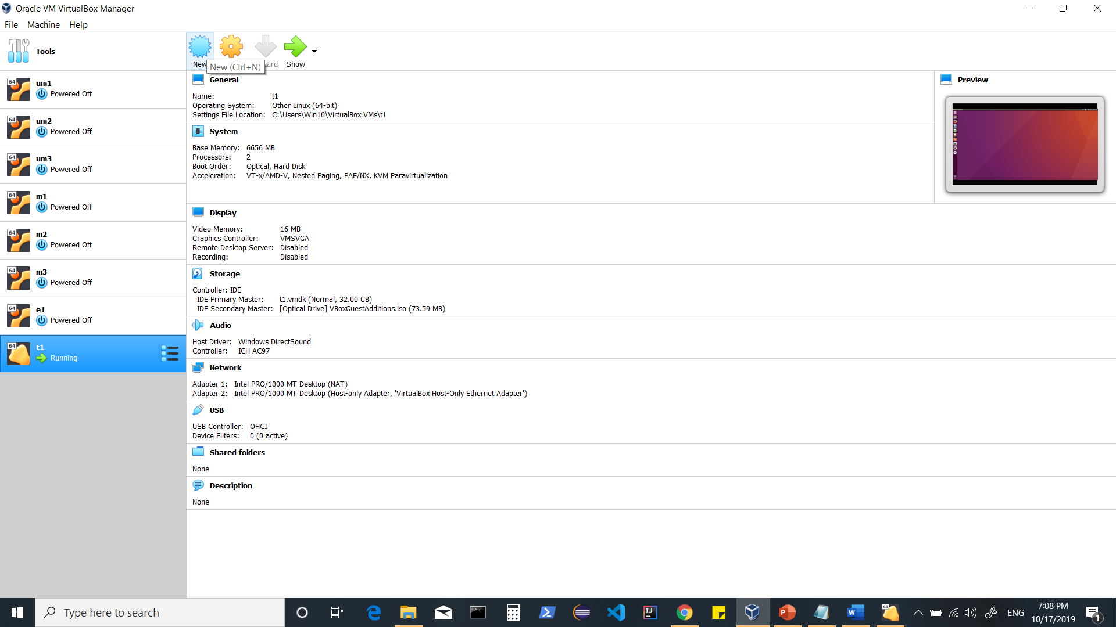

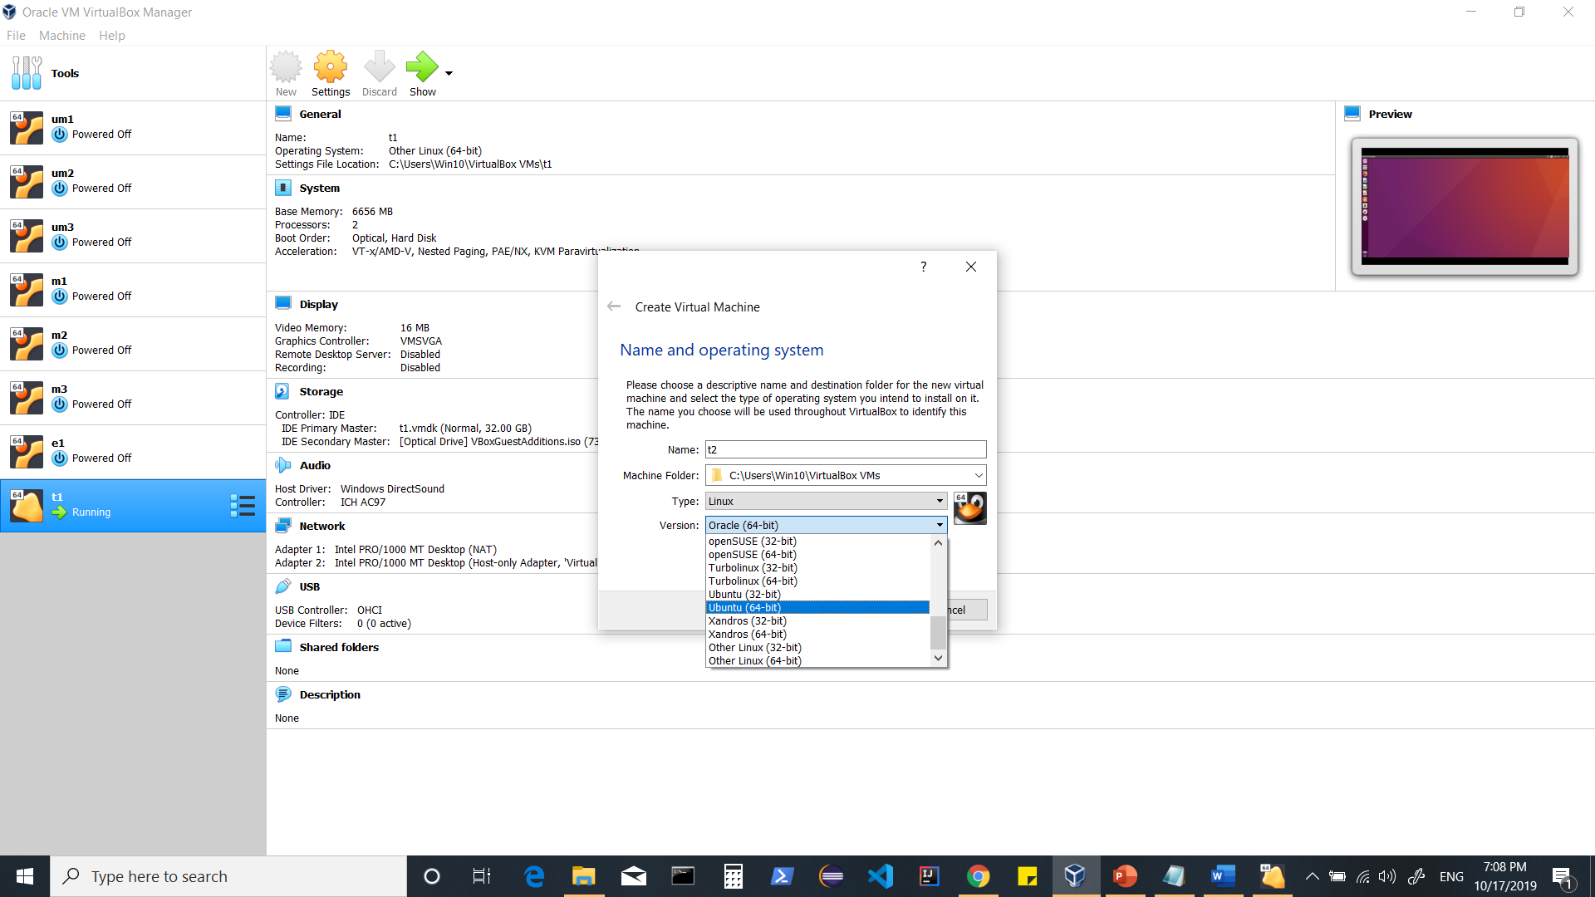

**Choose ram as per your machine’s configuration**

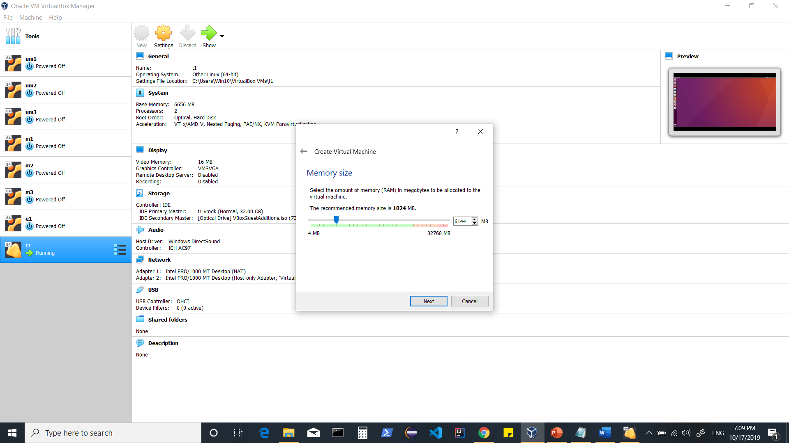

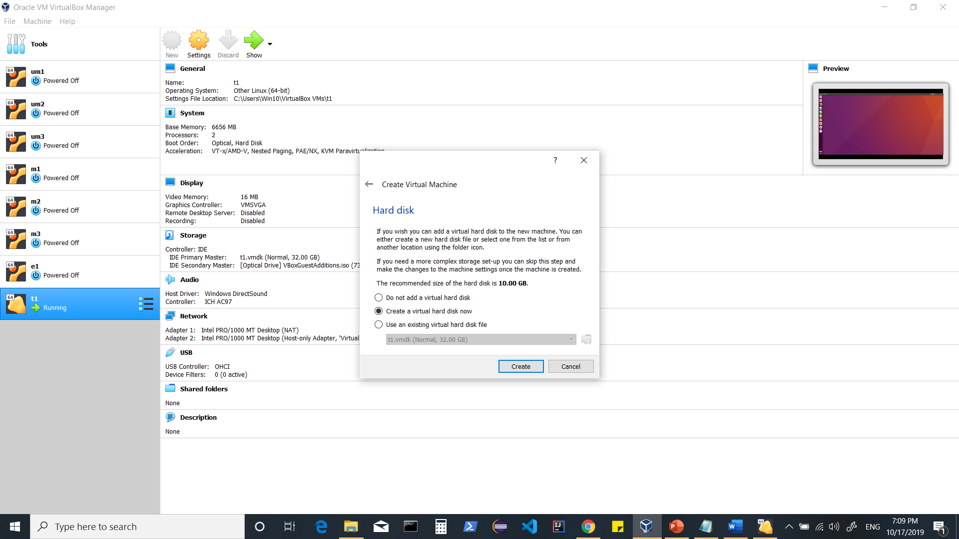

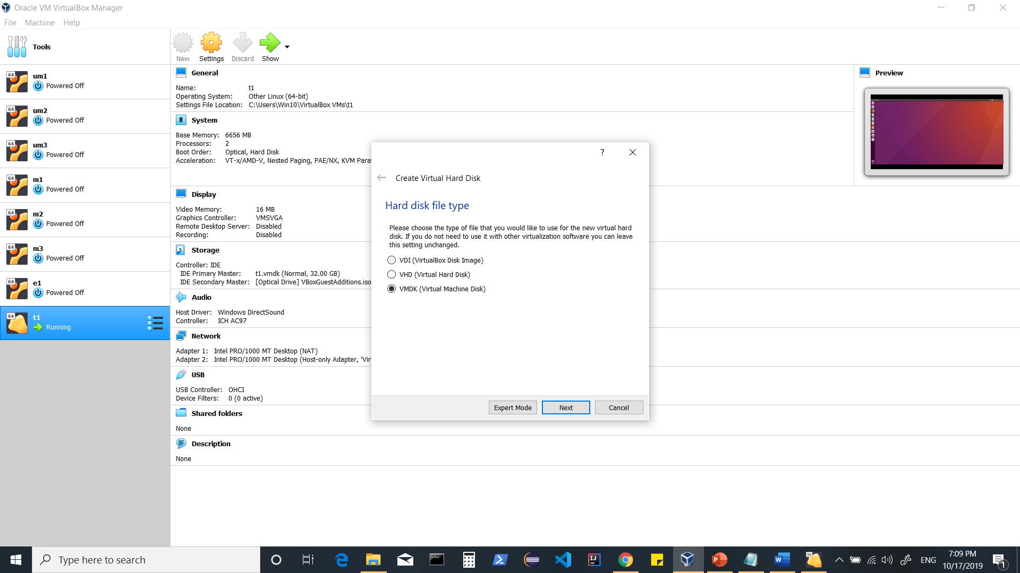

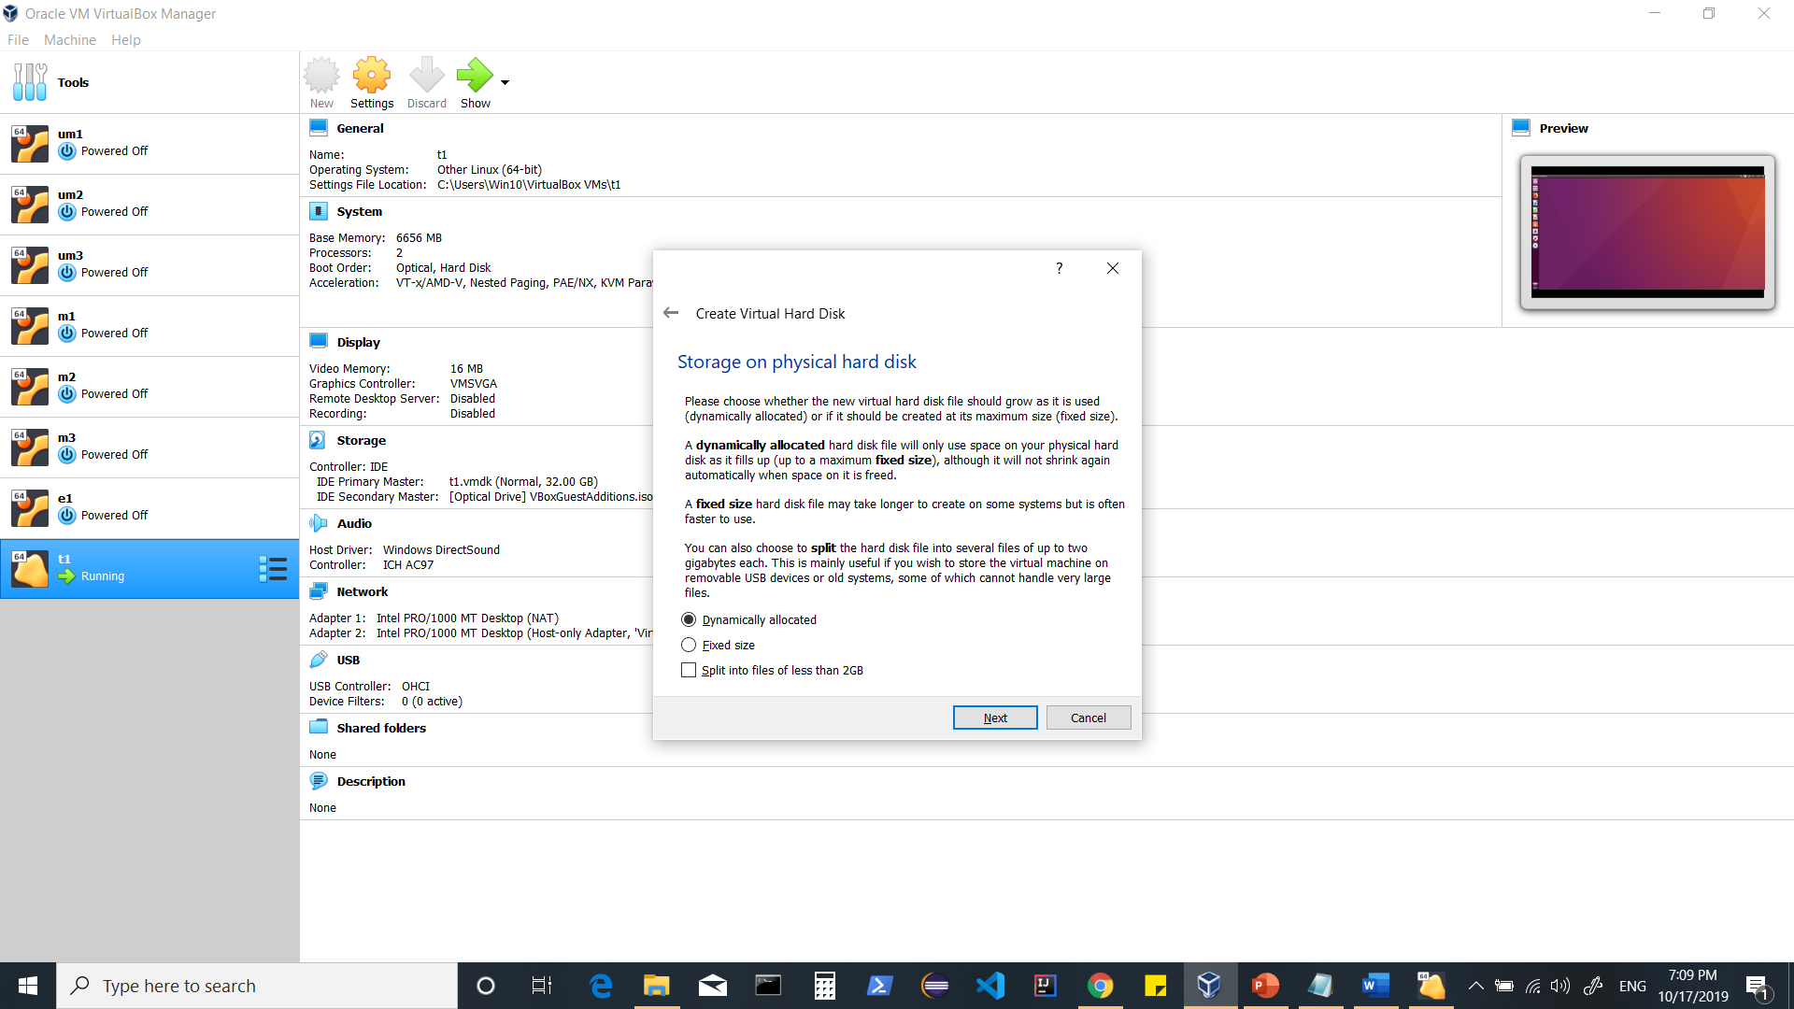

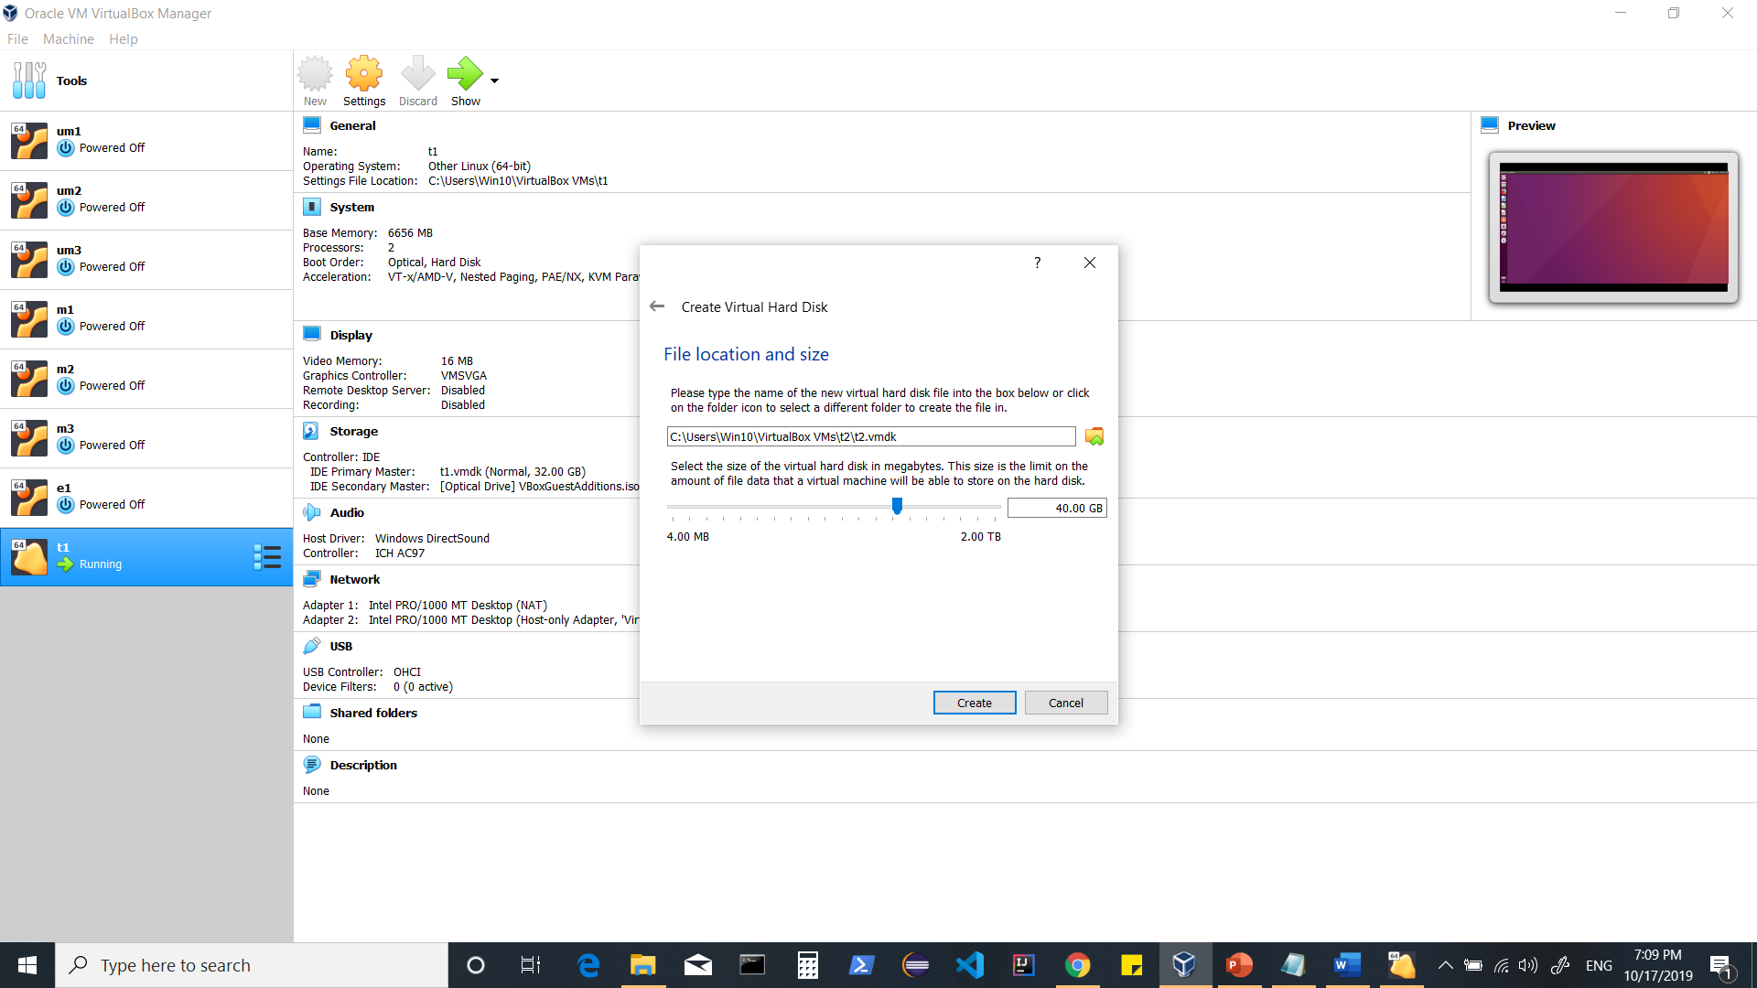

**Now machine is created.**

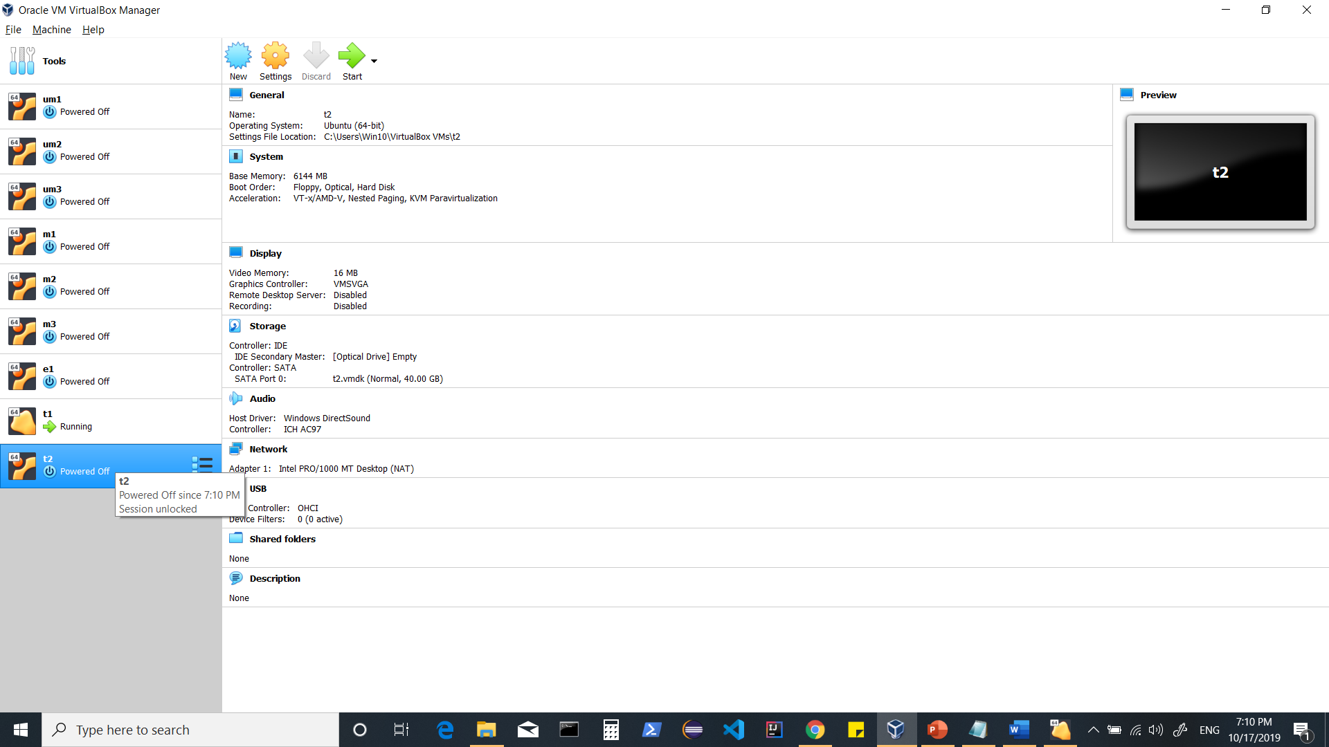

**Changing settings for your newly added machine to install Ubuntu.**

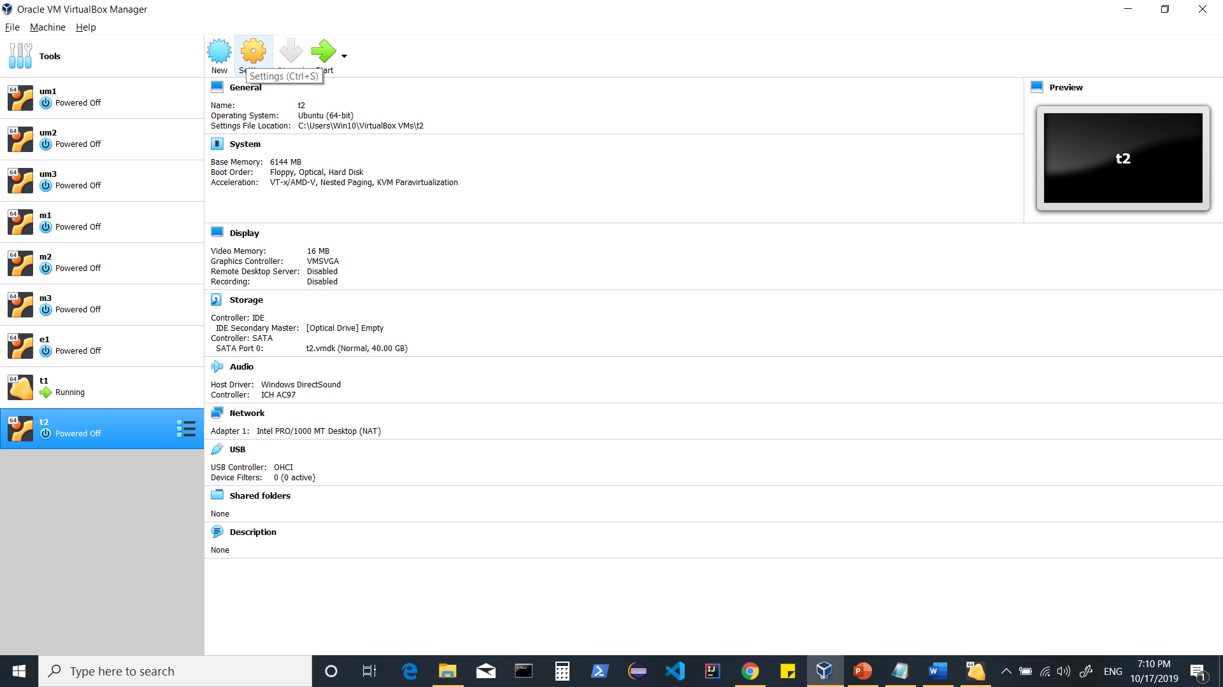

**System > Motherboard (tab) > uncheck Floppy**

**>increase/decrease ram**

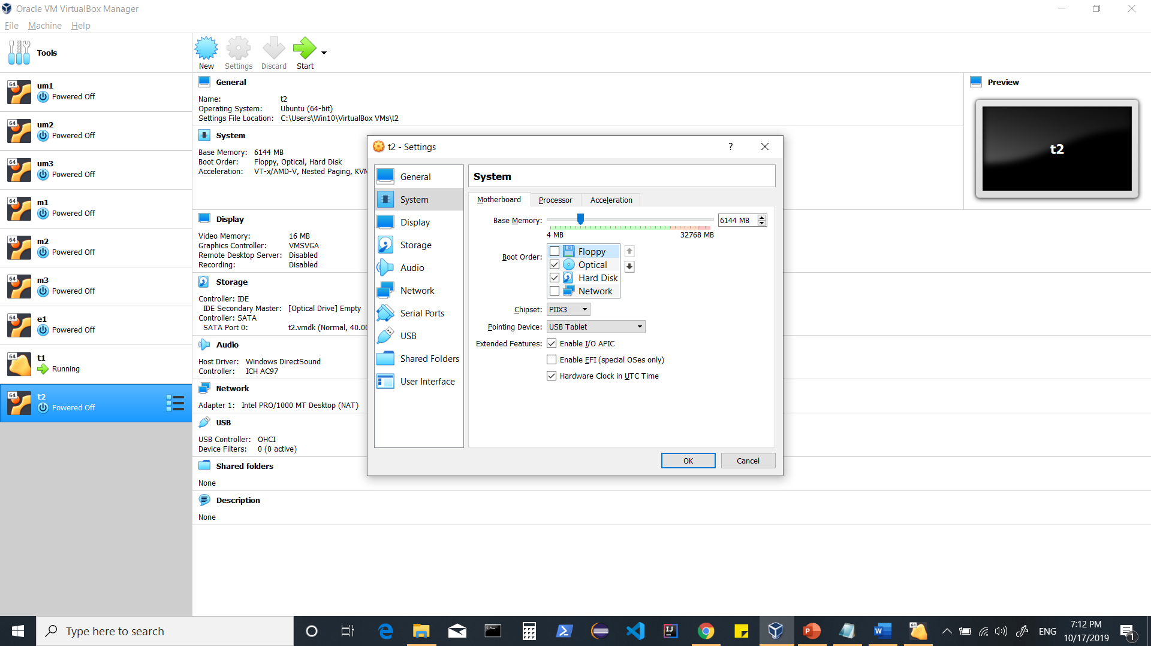

**> Processor > increase/decrease CPU**

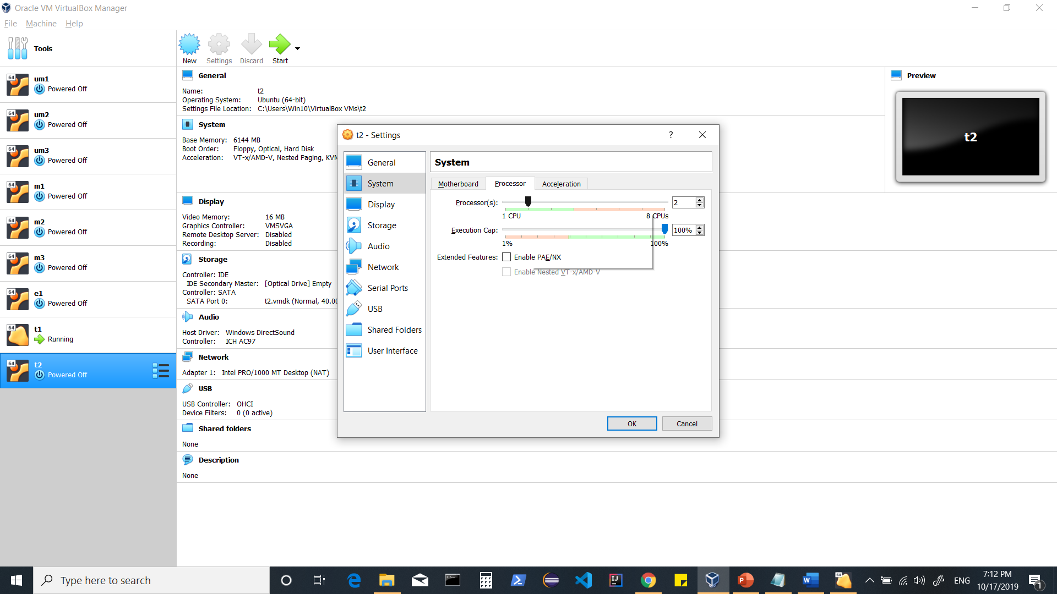

**Storage > choose the iso file (should be already downloaded)**

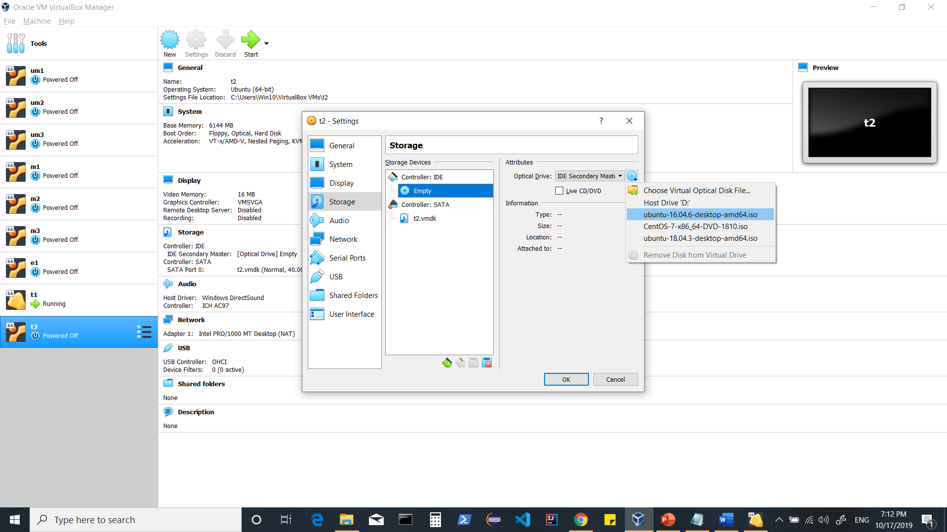

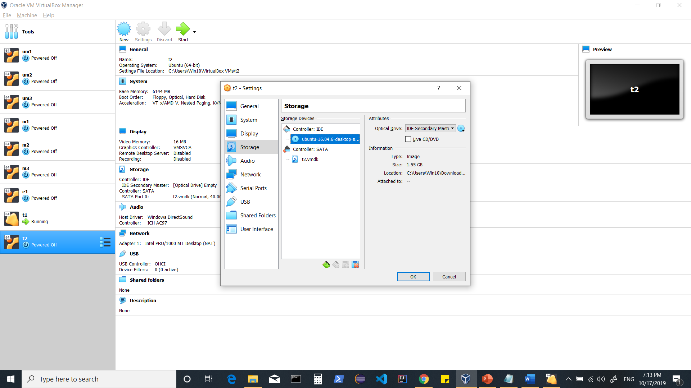

**Network >**

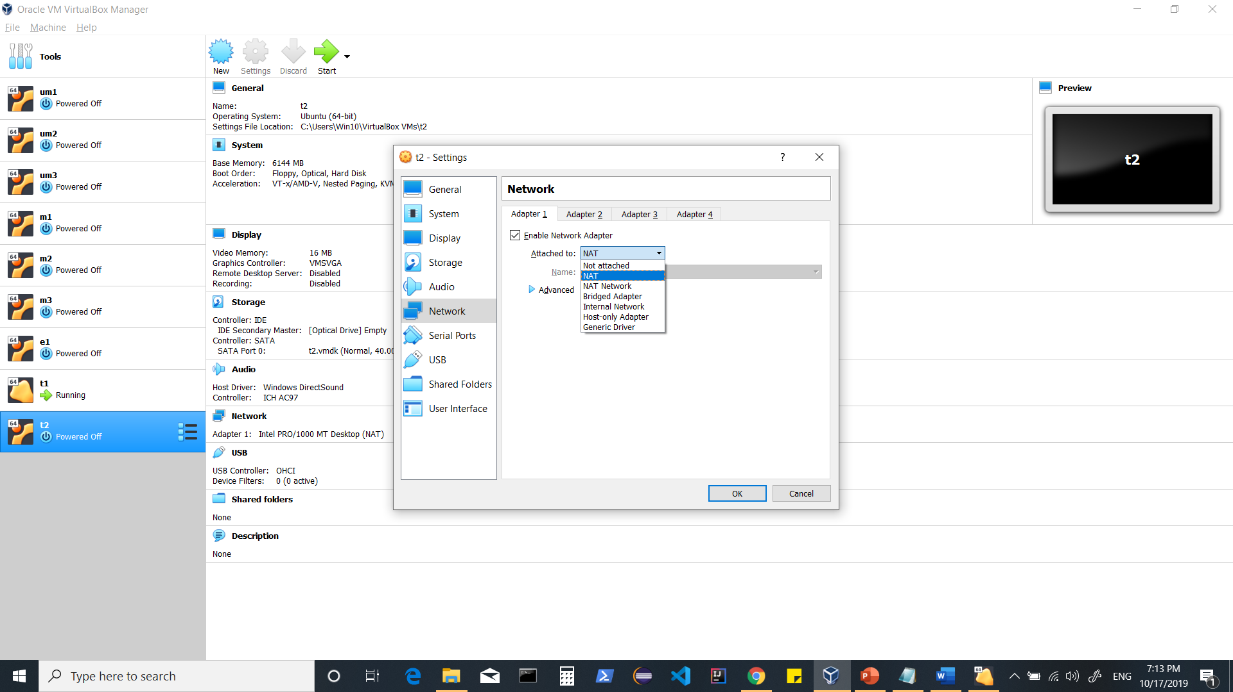

**We can use**

1. **NAT (if we intend to use only one machine)**
2. **BRDIGED ADAPTER (if we want each machine to have a different IP Address)**
3. **Or (NAT + Host Only Adapter)**

**Note** For Host Only Adapter, there are additional steps required. Scroll to the end of document and look for section “using host only adapter”**

**For now, I will use NAT**

**Start your machine…**

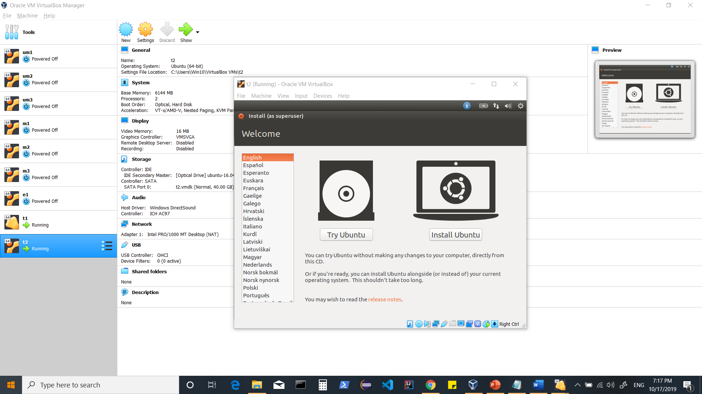

**Click on Install Ubuntu**

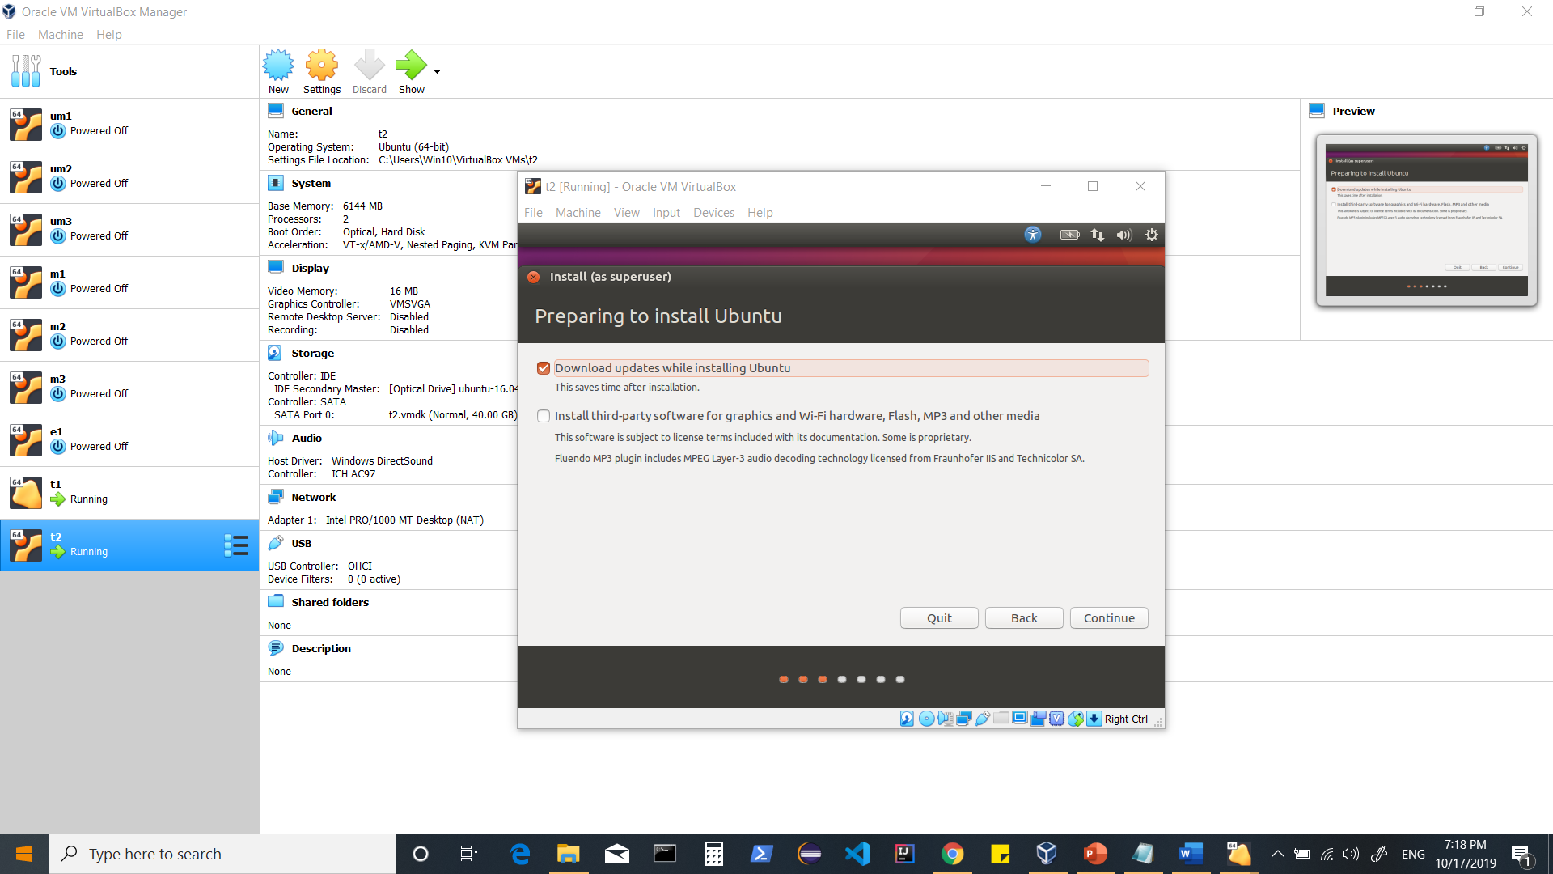

**Continue**

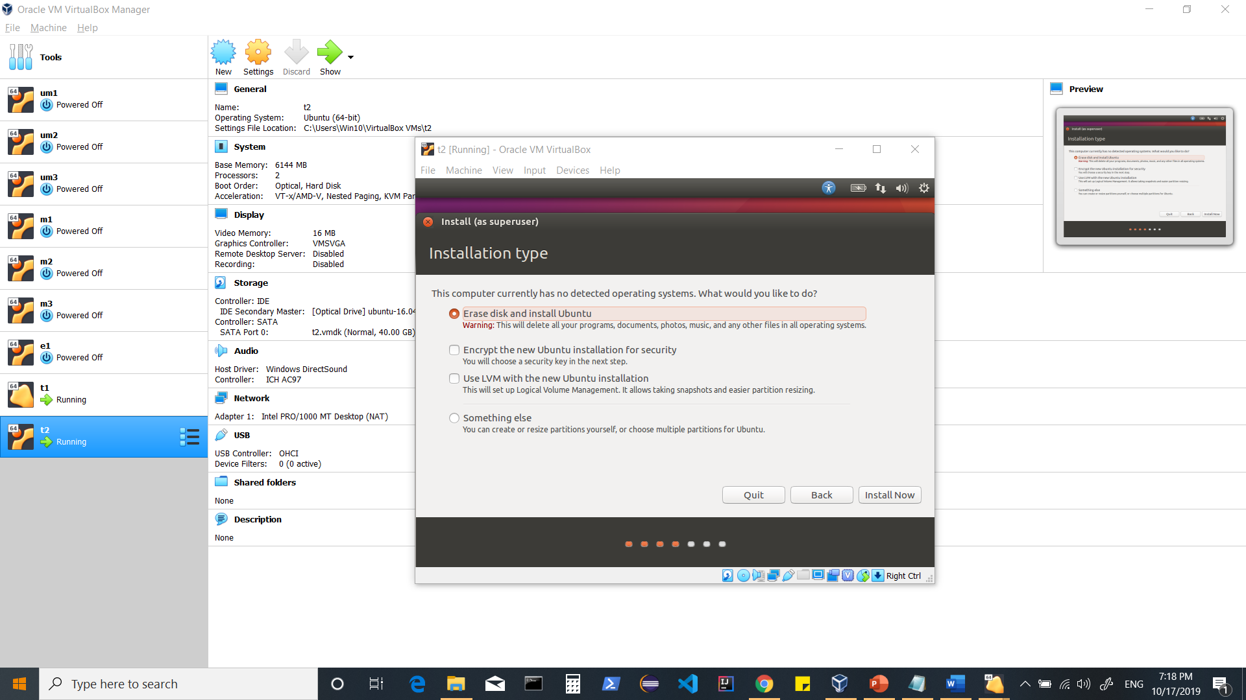

**Install now**

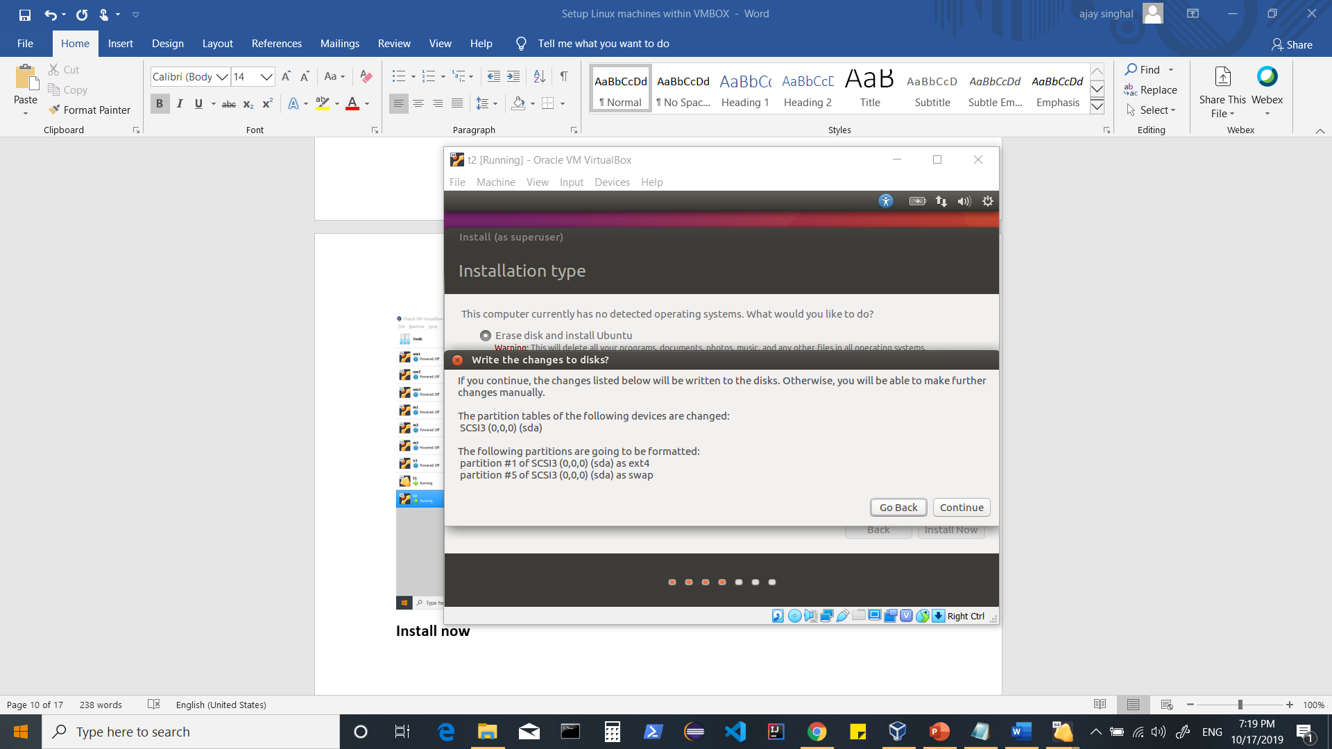

**Continue**

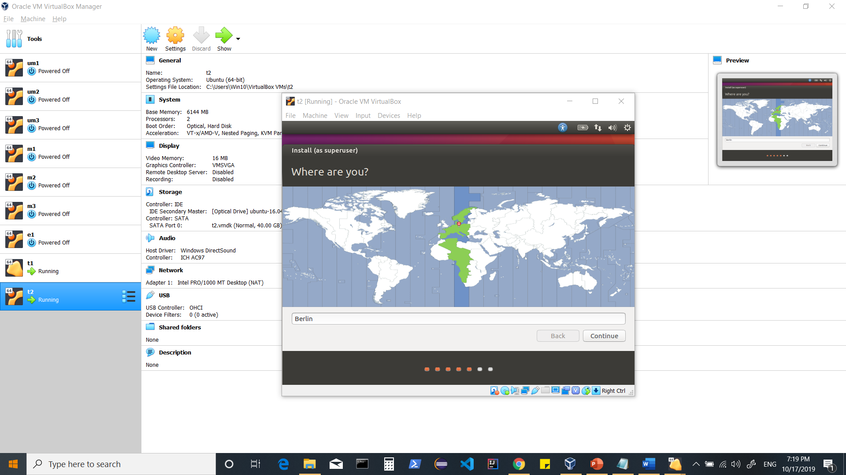

**Continue**

**On screen when it shows languages, hit <tab> for 5 times + <enter>**

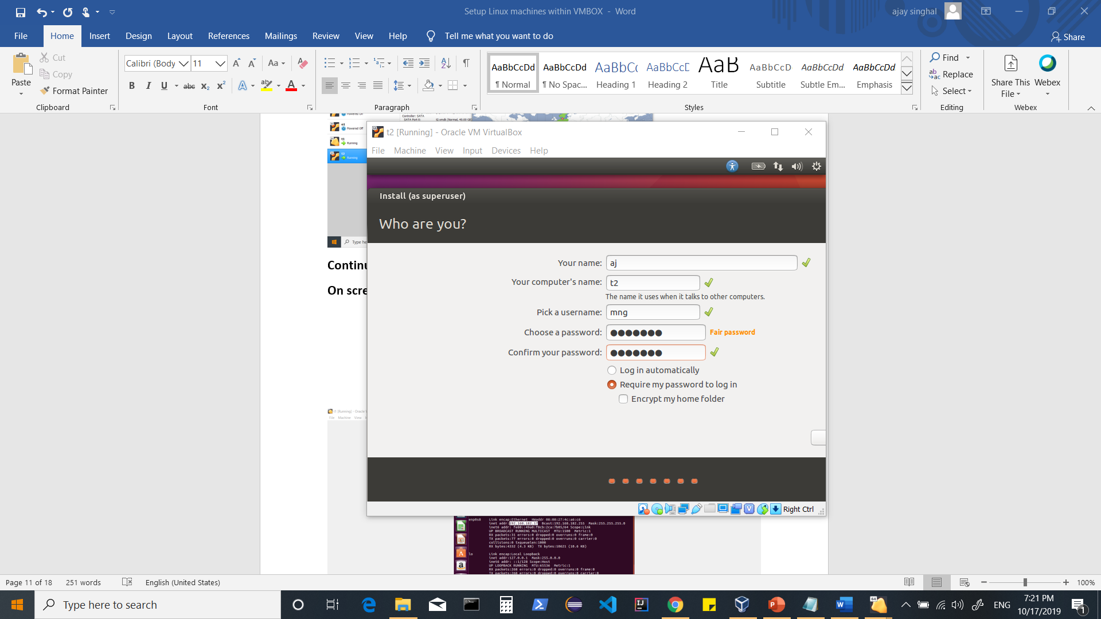

**Give details and hit <tab> for 4 times + <enter>**

**Now your installation starts, wait for it to complete and restart your machine.**

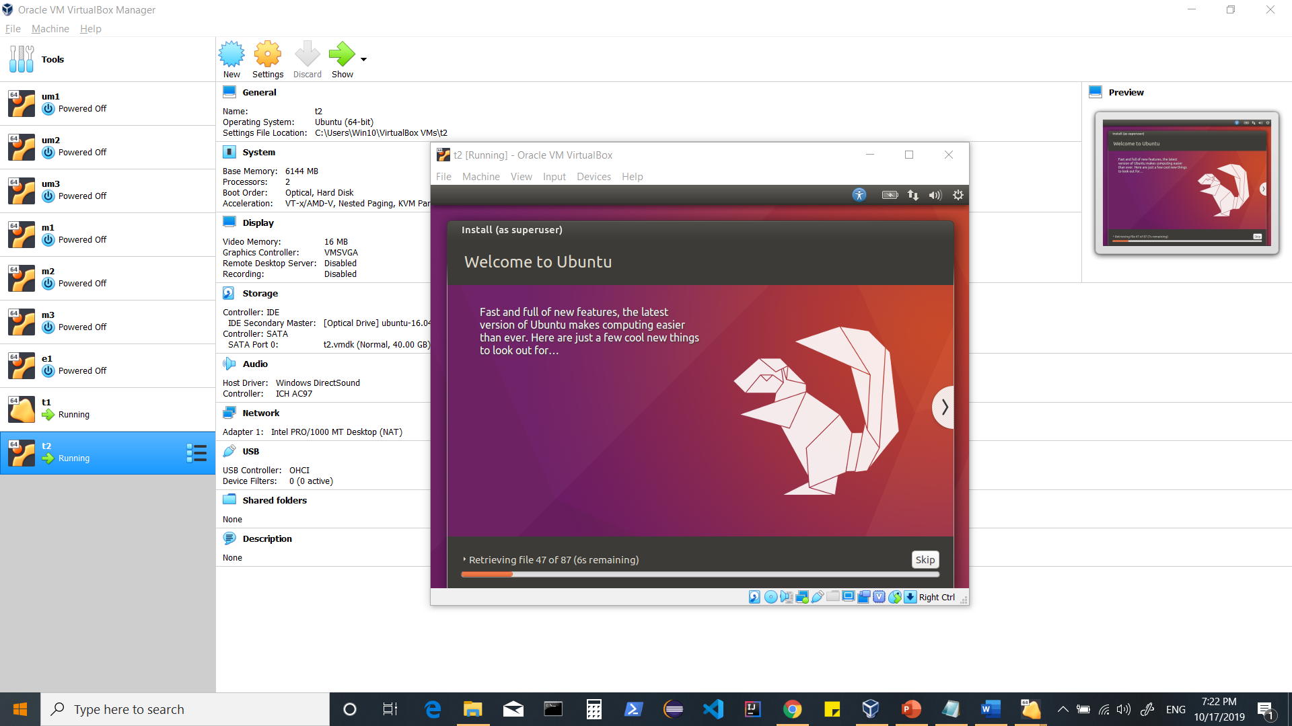

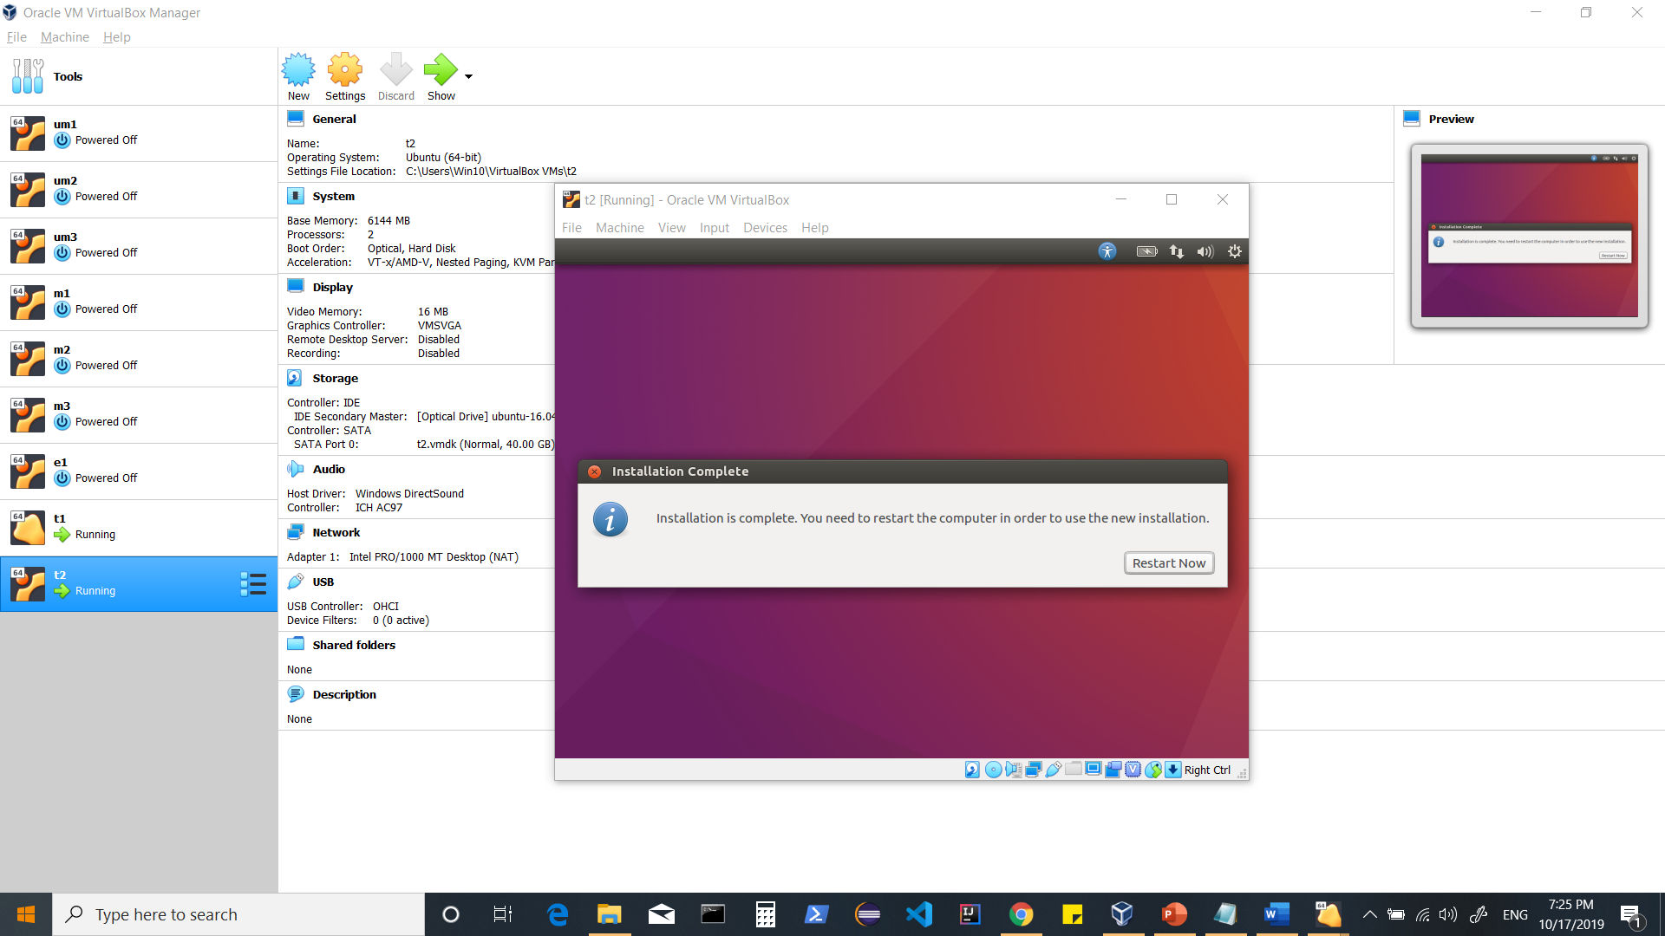

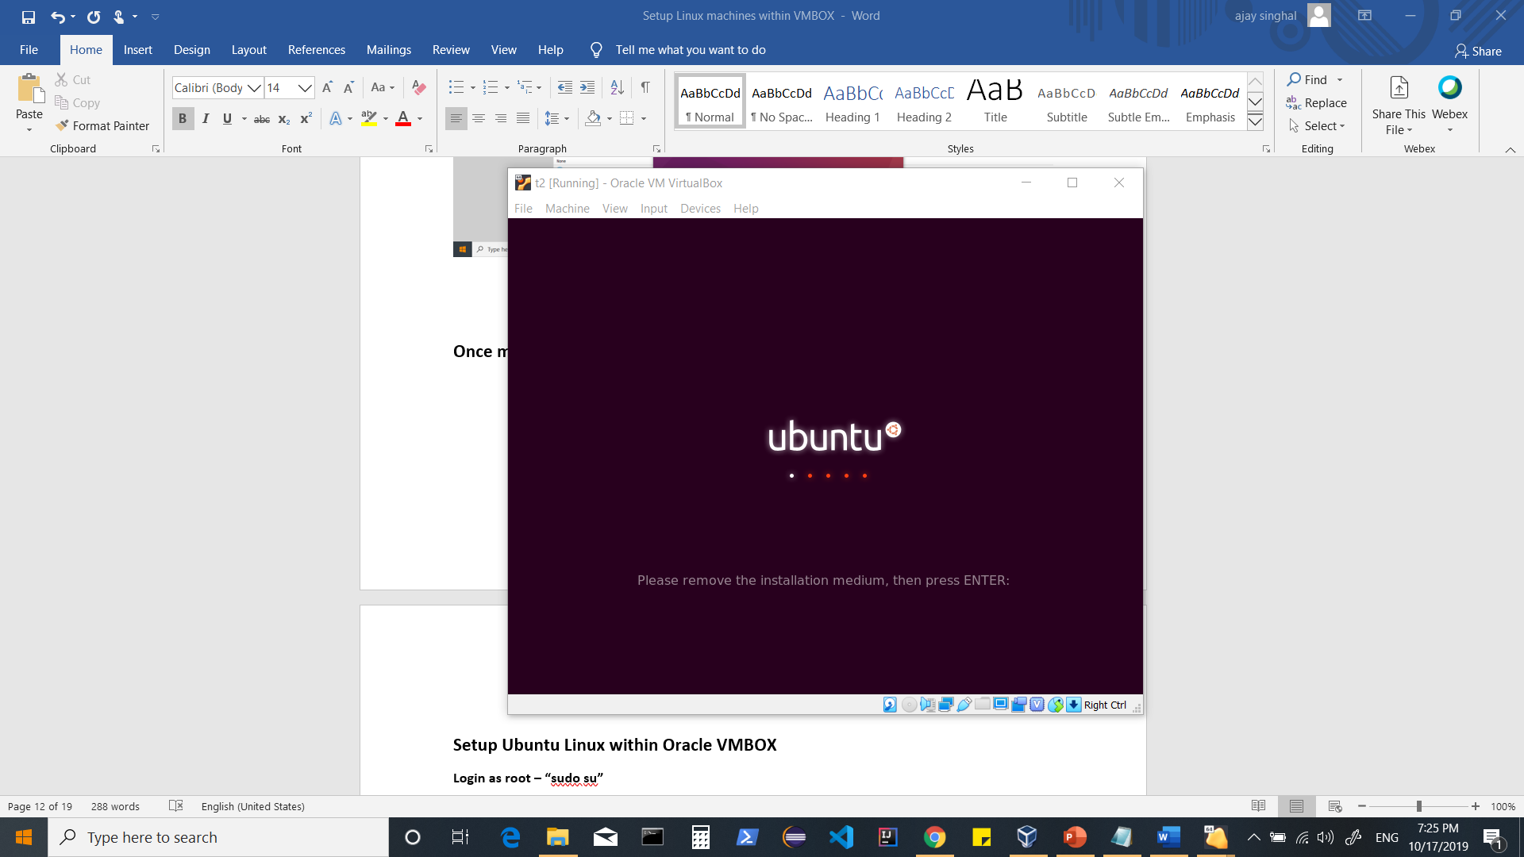

**Once machine is restarted…follow the steps below to “Setup Ubuntu Linux within Oracle VMBOX”**

**Login as root – “sudo su”**

**$ifconfig (to check your ipaddress)**

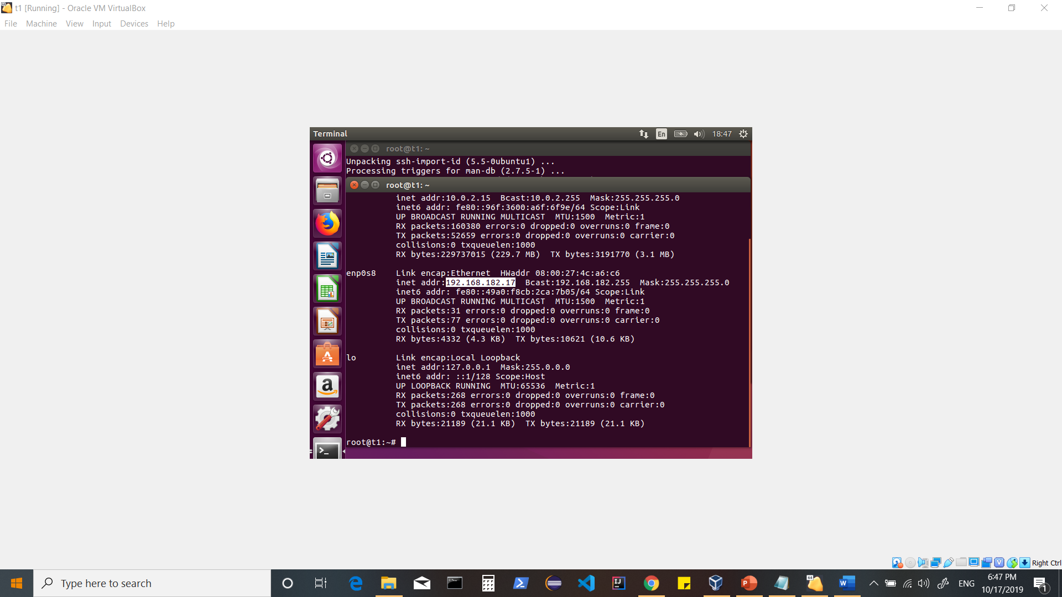

**Update /etc/hosts for host to IP resolution (if you don’t have a DNS)**

**vi /etc/hosts**

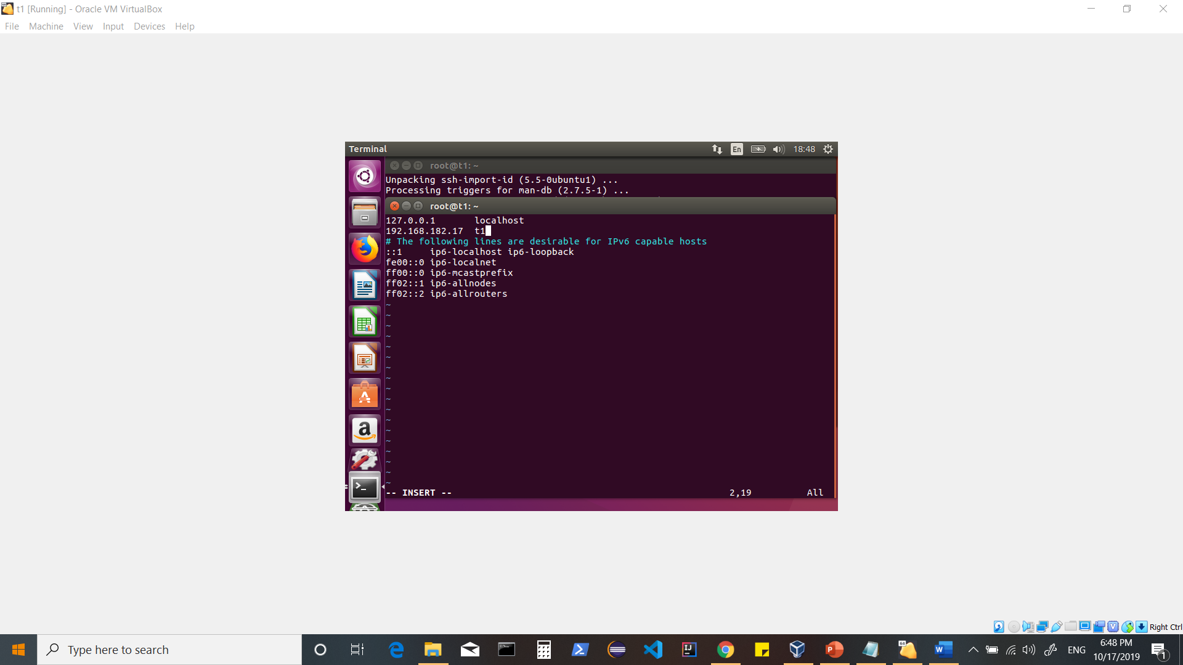

**<esc>**

**<shift+:+wq>**

**Install Packages**

**vim**

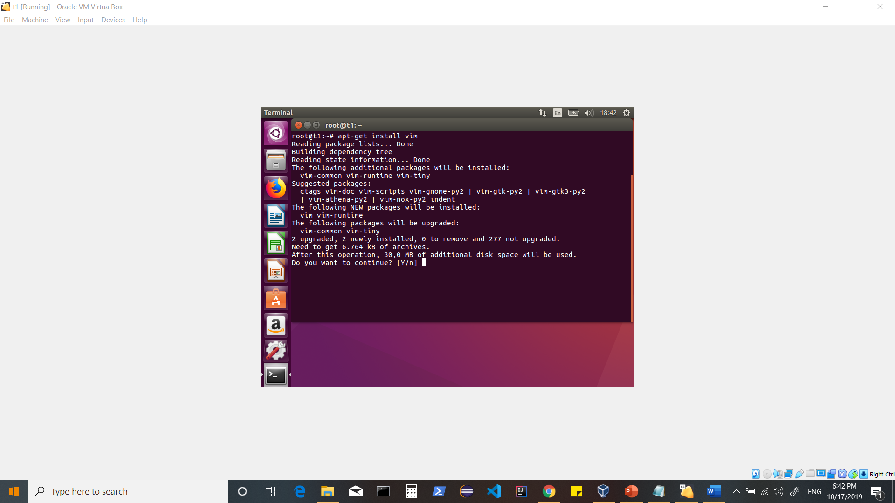

**wget**

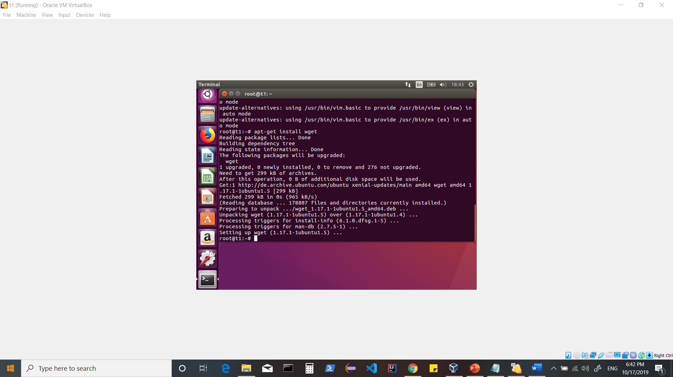

**openssh-server**

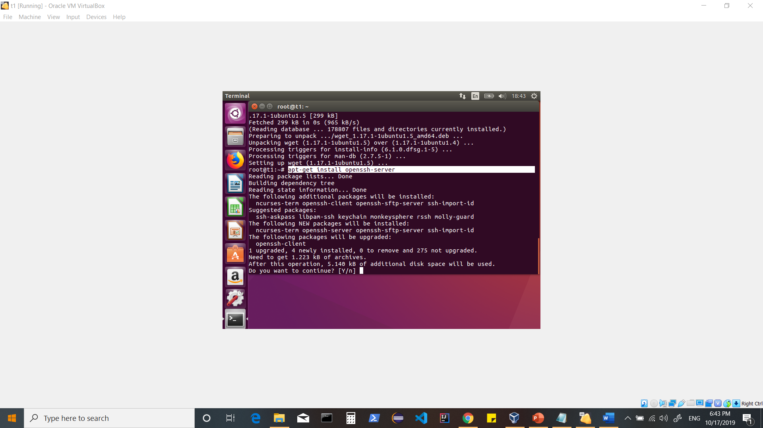

**Disable firewall**

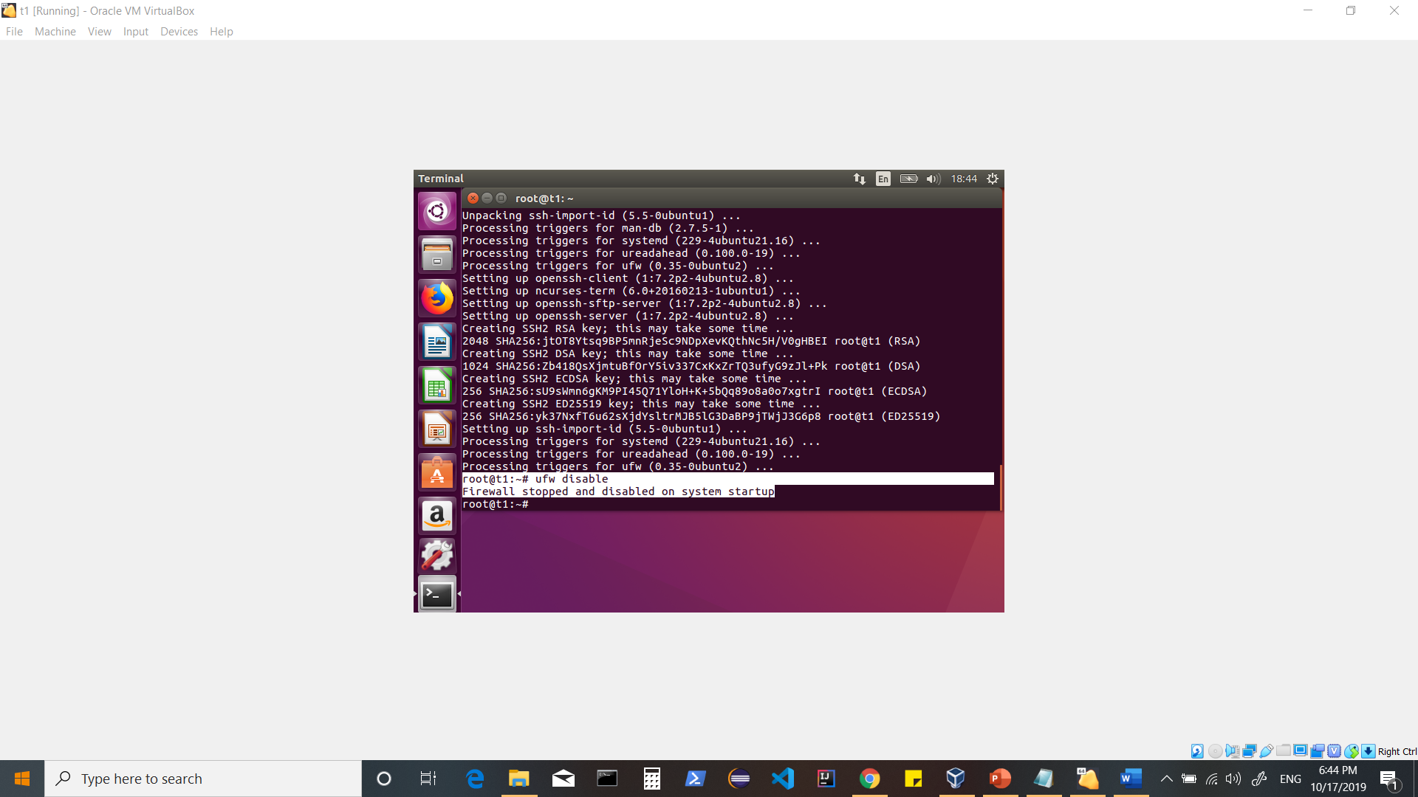

**Update Packages**

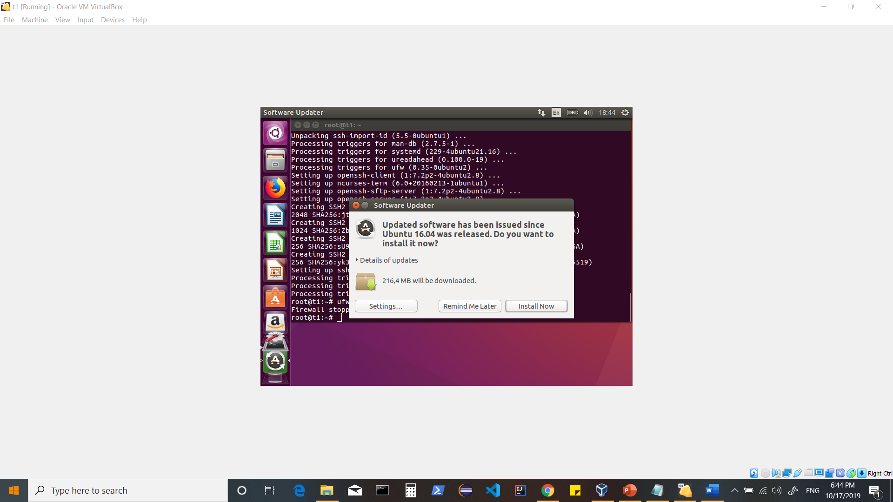

**Once done,**

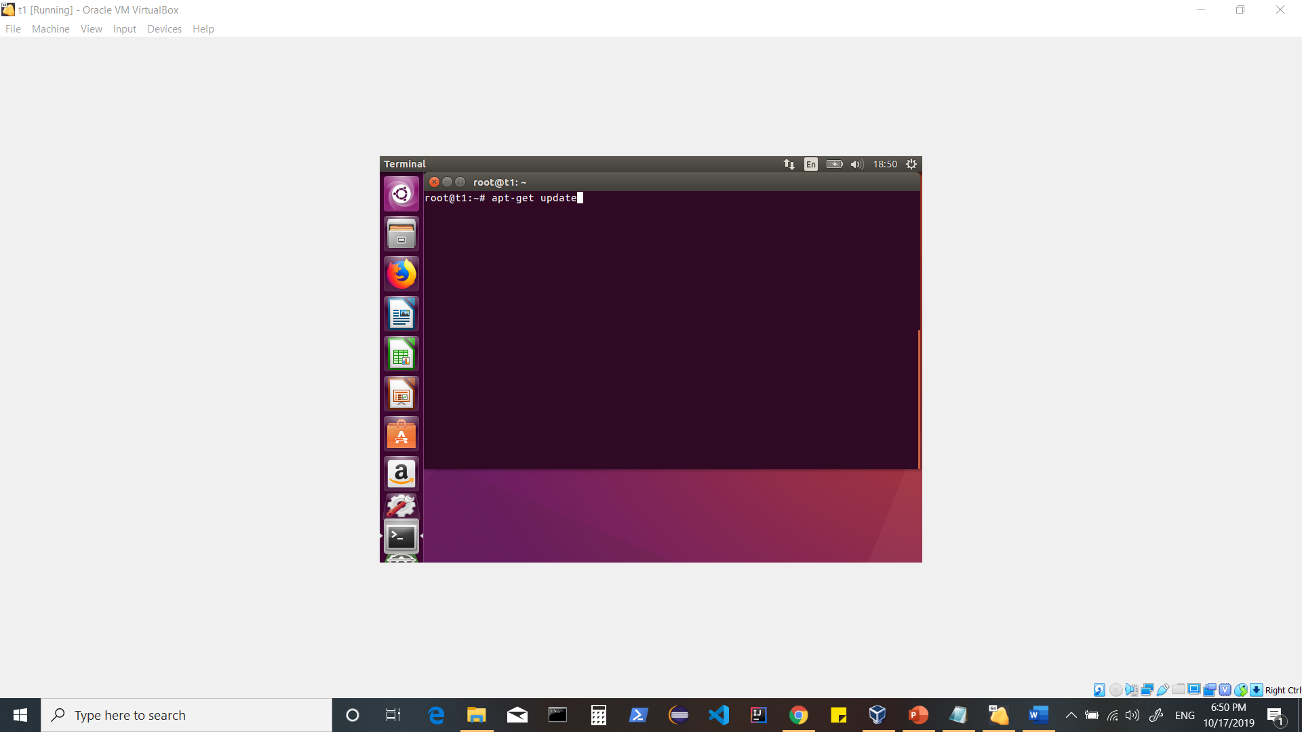

**Now let’s install packages for kernel to make your screen full screen.**

**[This would not be required from Ubuntu 18.x onwards ]**

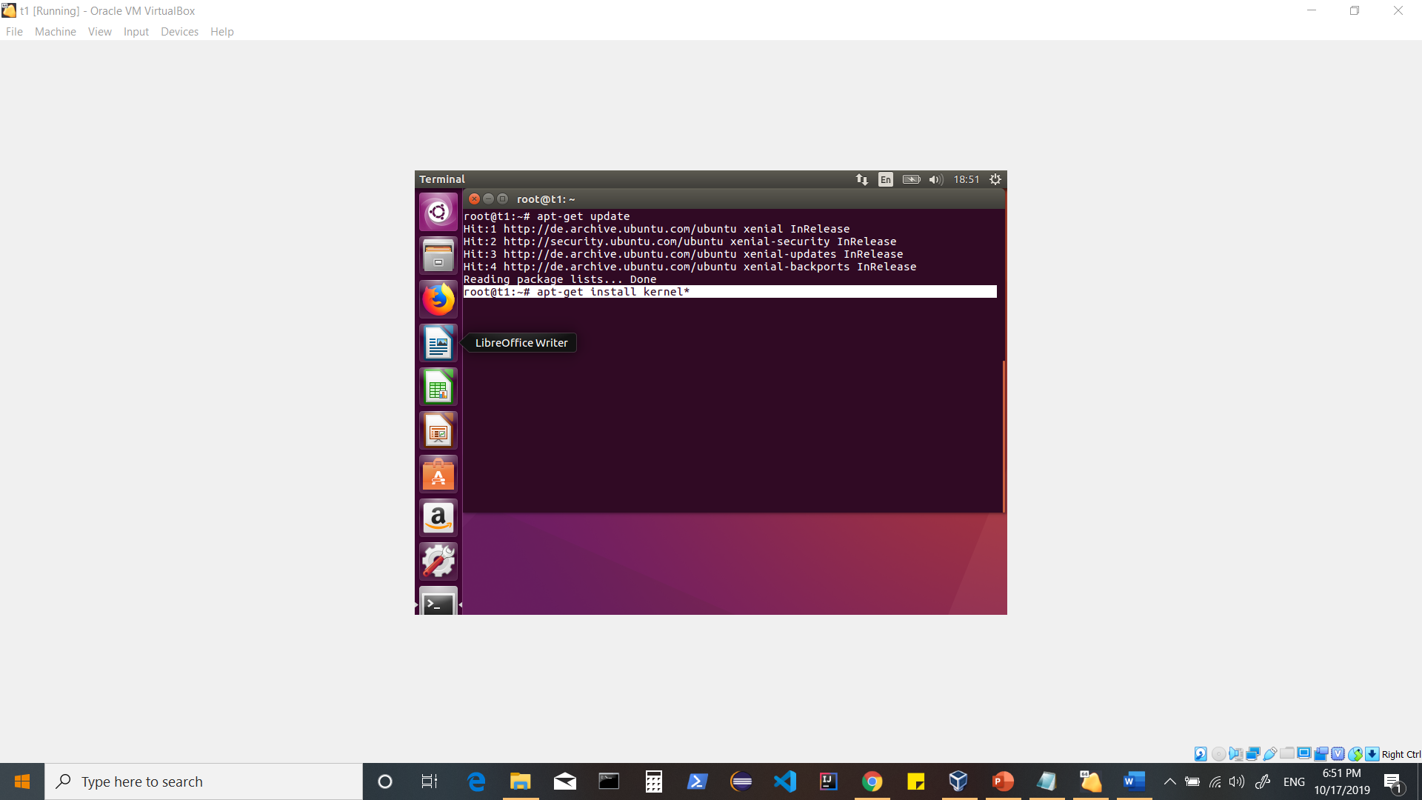

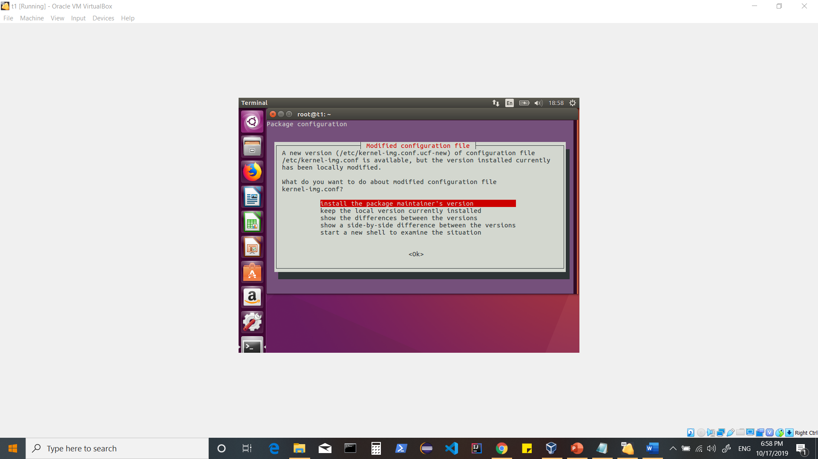

**Once done, Now let’s add the Guest Addition**

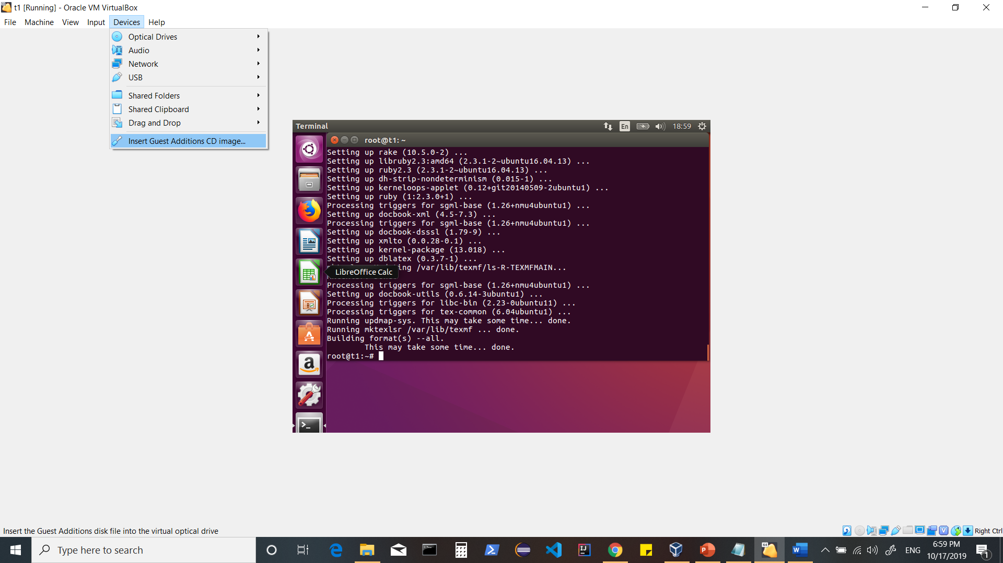

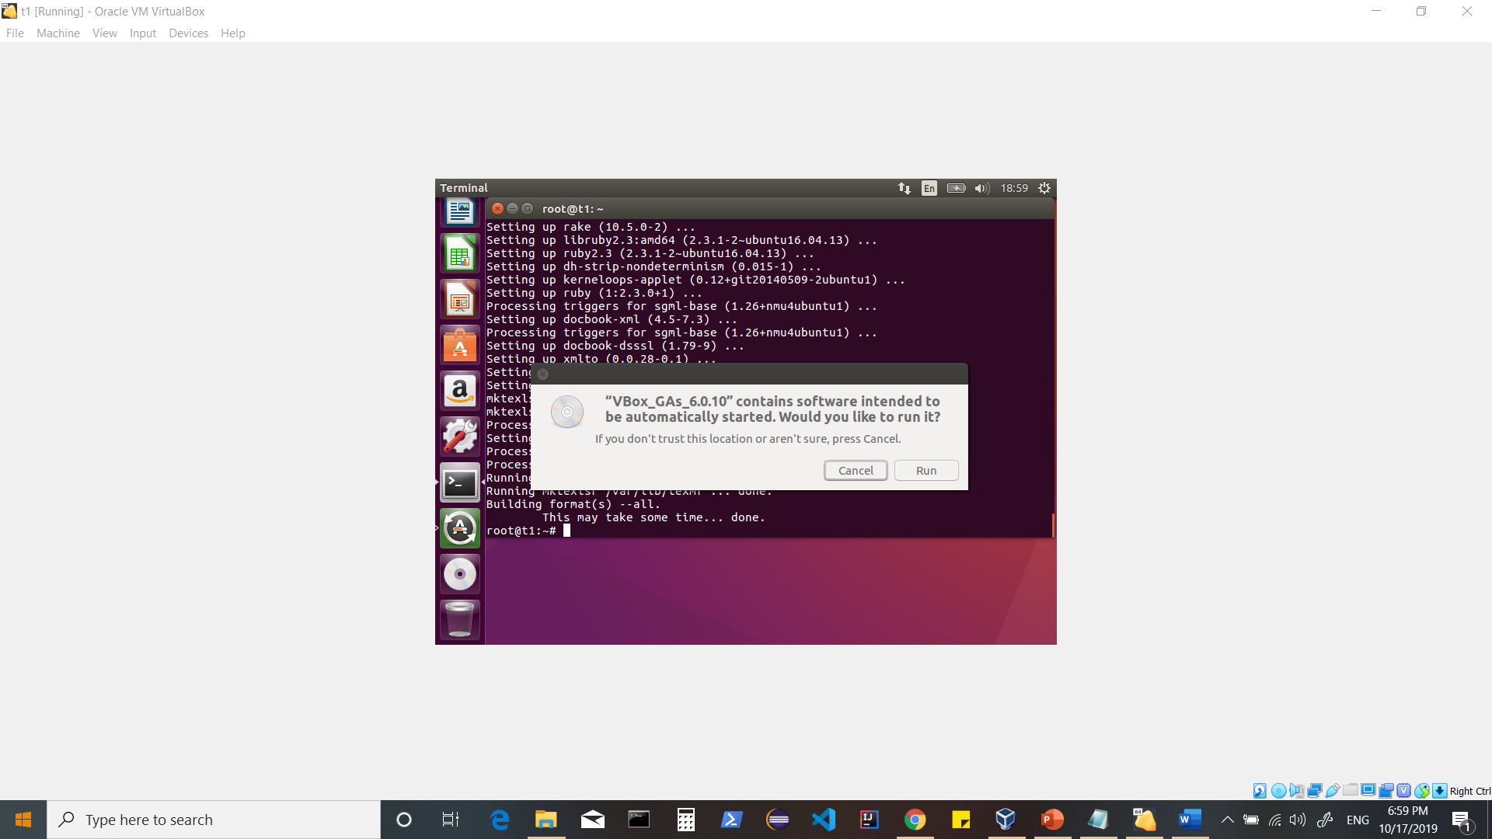

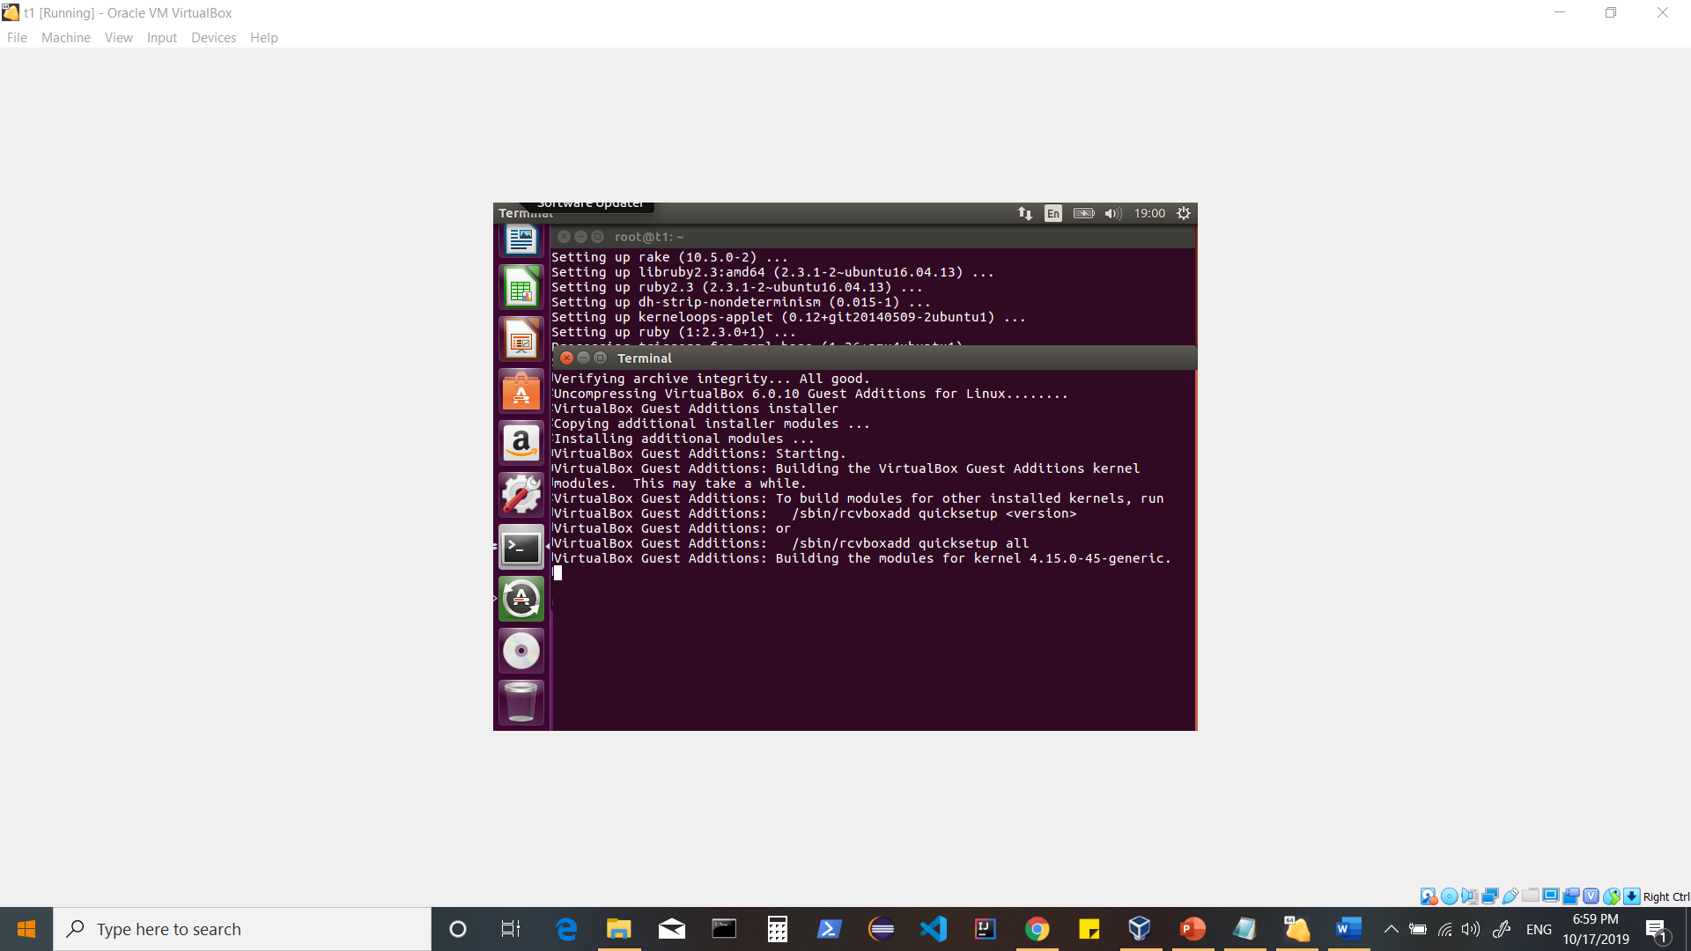

**Wait for this to complete and then Restart your machine.**

**Now the machine is converted to FULL SCREEN MODE**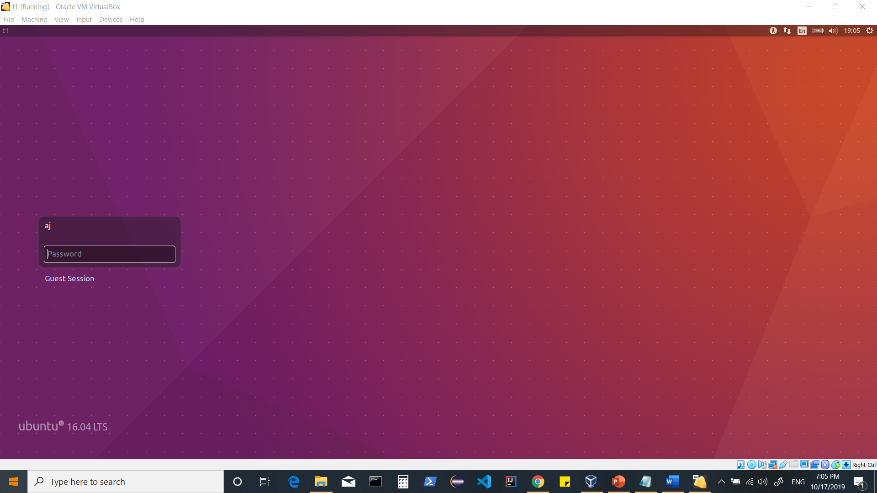

**Using host only adapter**

**To setup network using NAT + Host Only Adapter.**

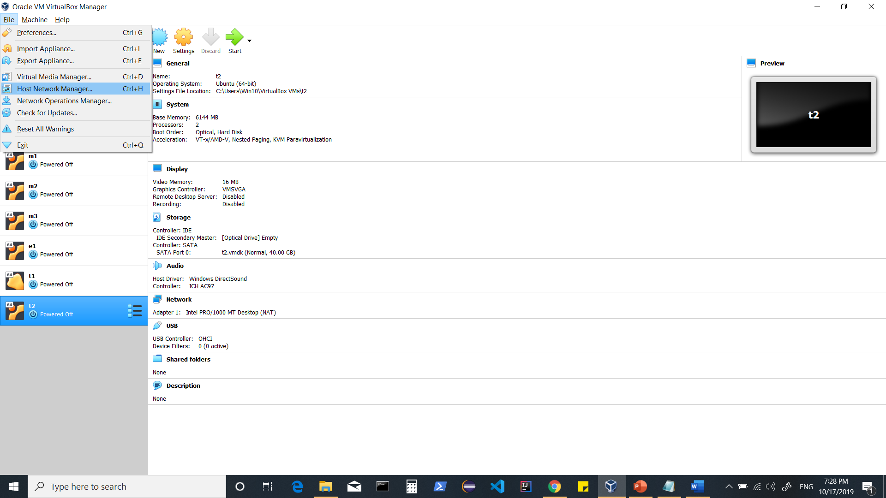

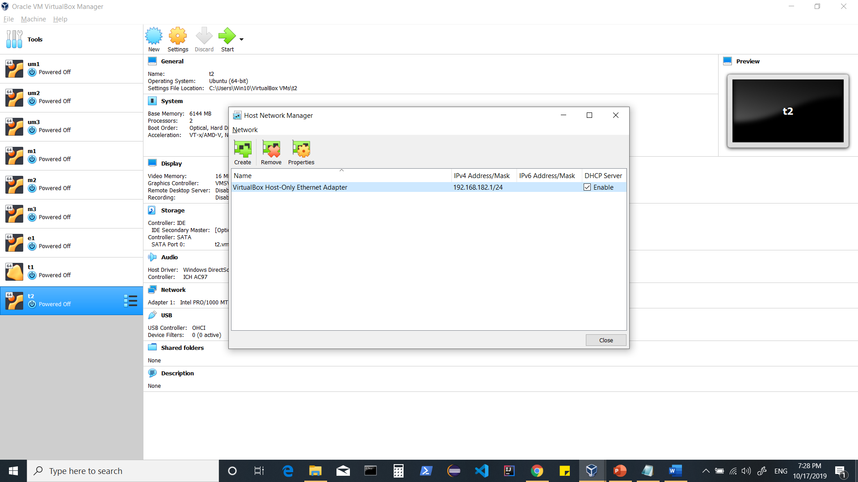

**If it shows as in above screen, select it and click on remove.**

**Click on create**

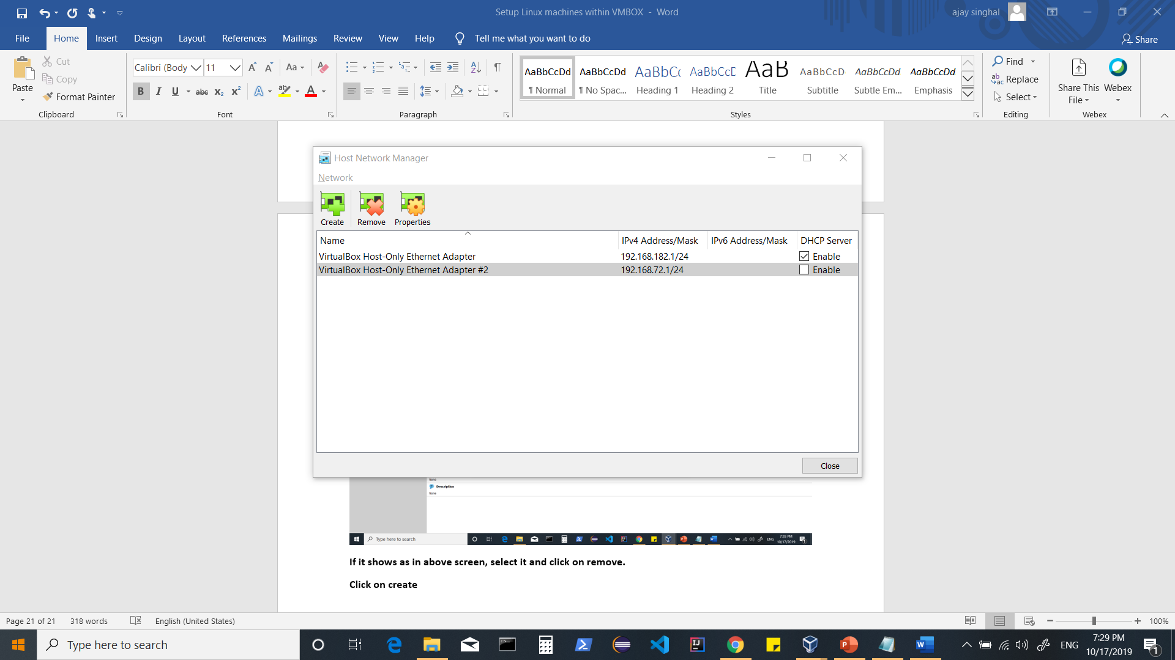

**Note** In my case, there was an Adapter thus it created one more.**

**Enable the host only adapter created.**

**Now for your machine**

**Let your Adapter 1 be NAT**

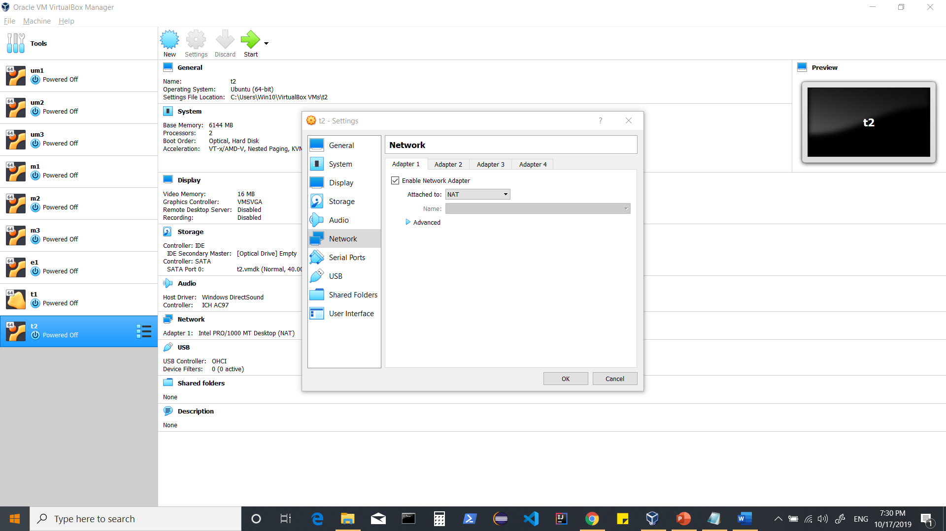

**Adapter 2**

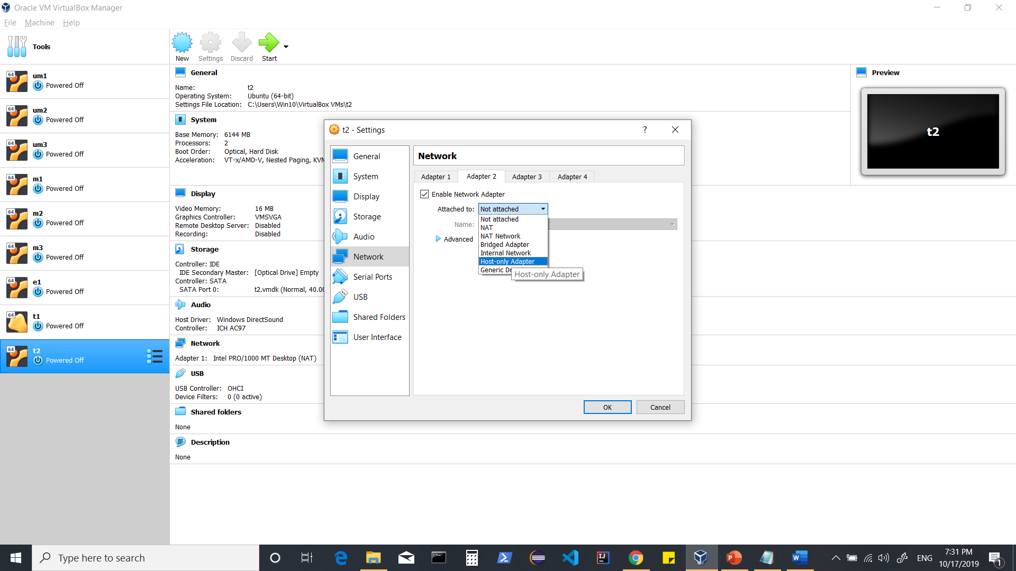

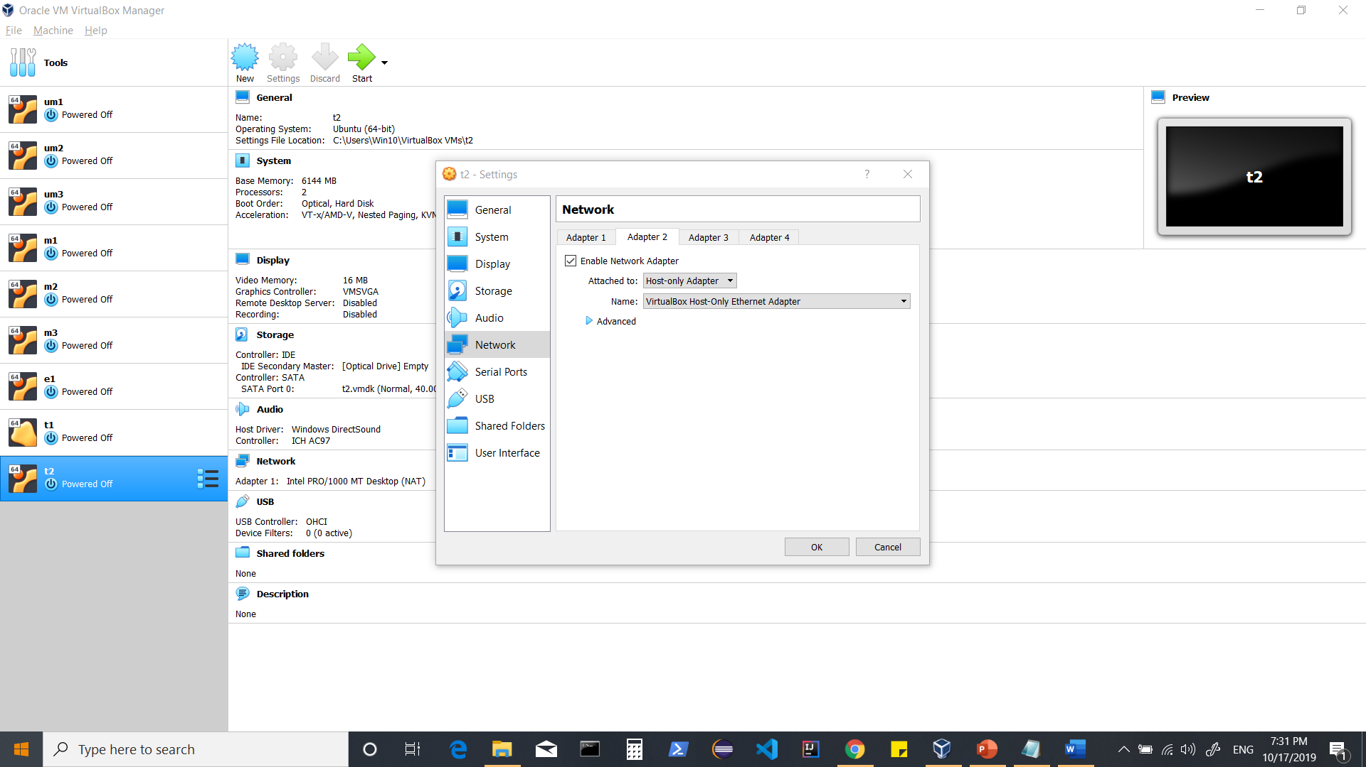

**<ok>**

**When machine is restarted, check your Ip-addresses using ‘ipconfig’.**

**Its should now show NAT and Host Only Adapter based, Ip-Addresses.**